**HOME PAGE:-**

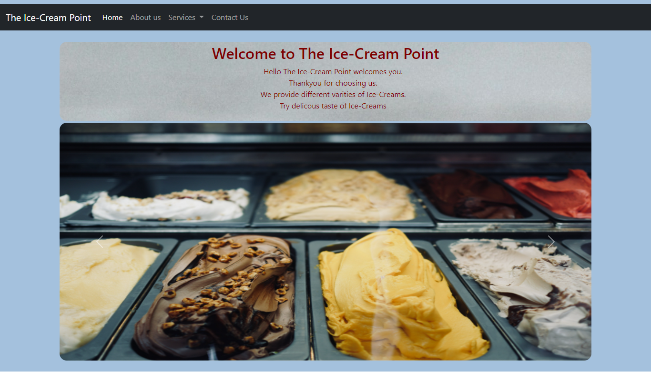

**ABOUT PAGE:-**

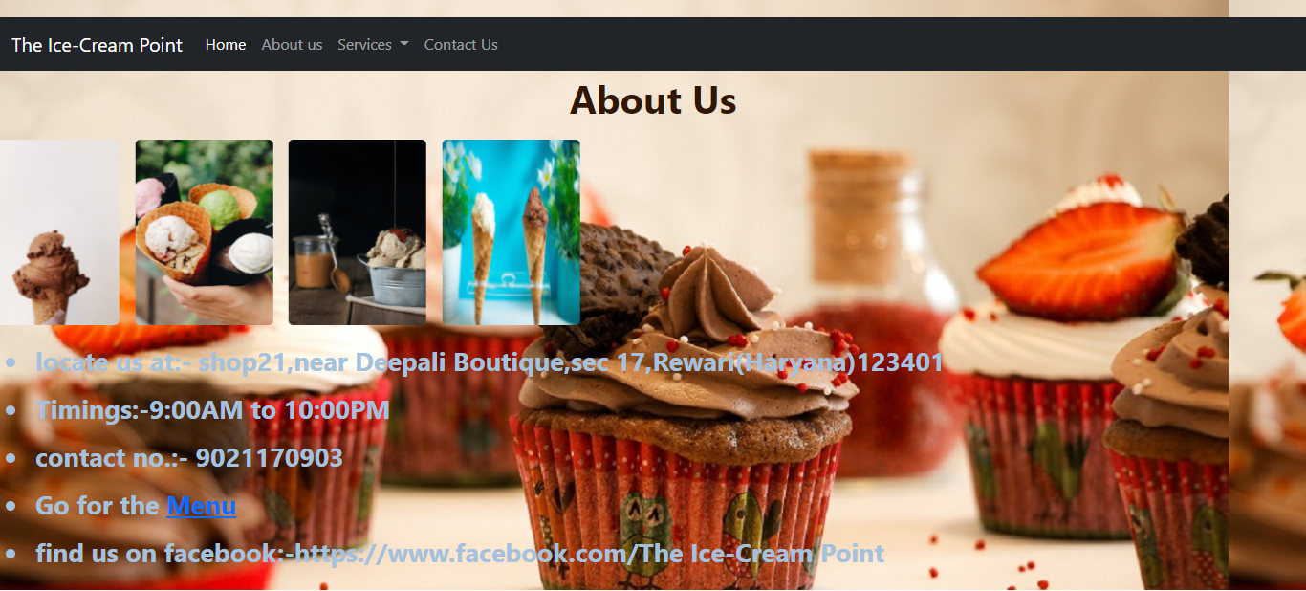

**MENU:-**

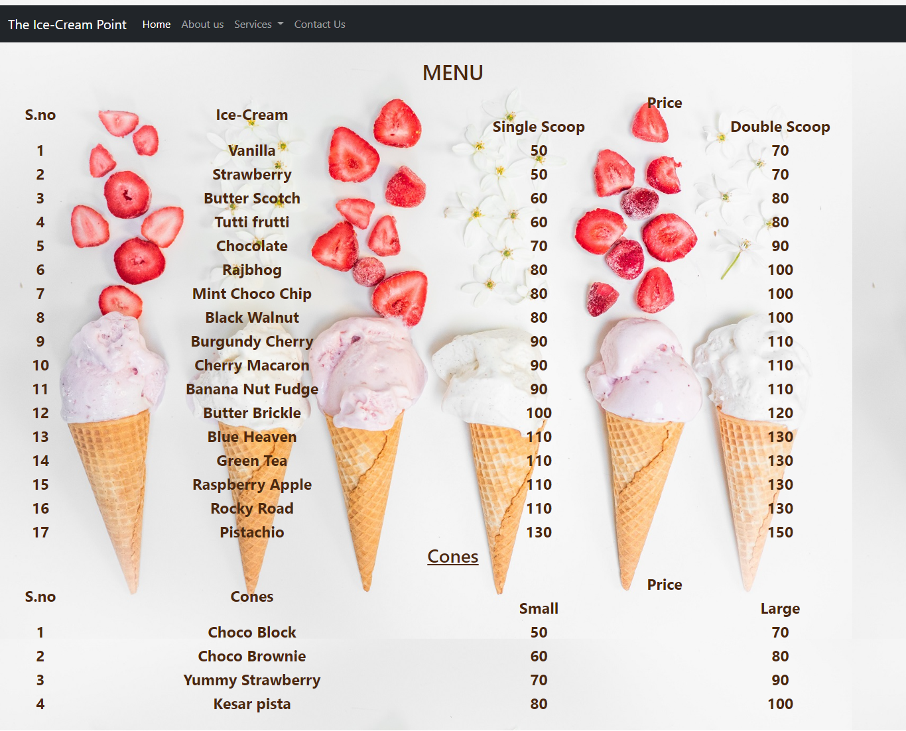

**SERVICES:-**

**PARTY HALL:-**

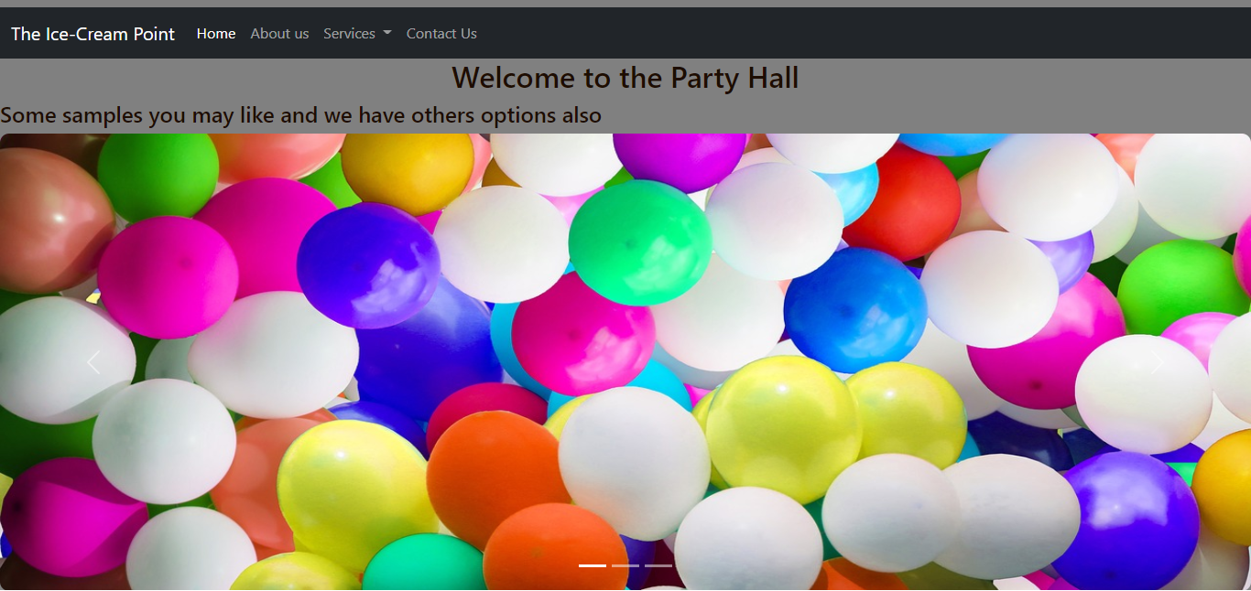

**WEDDING ORDER:-**

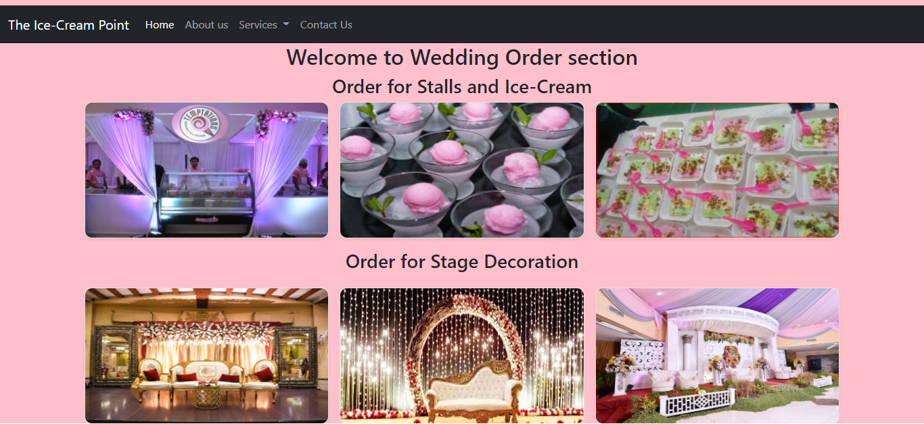

**CONTACT US:-**

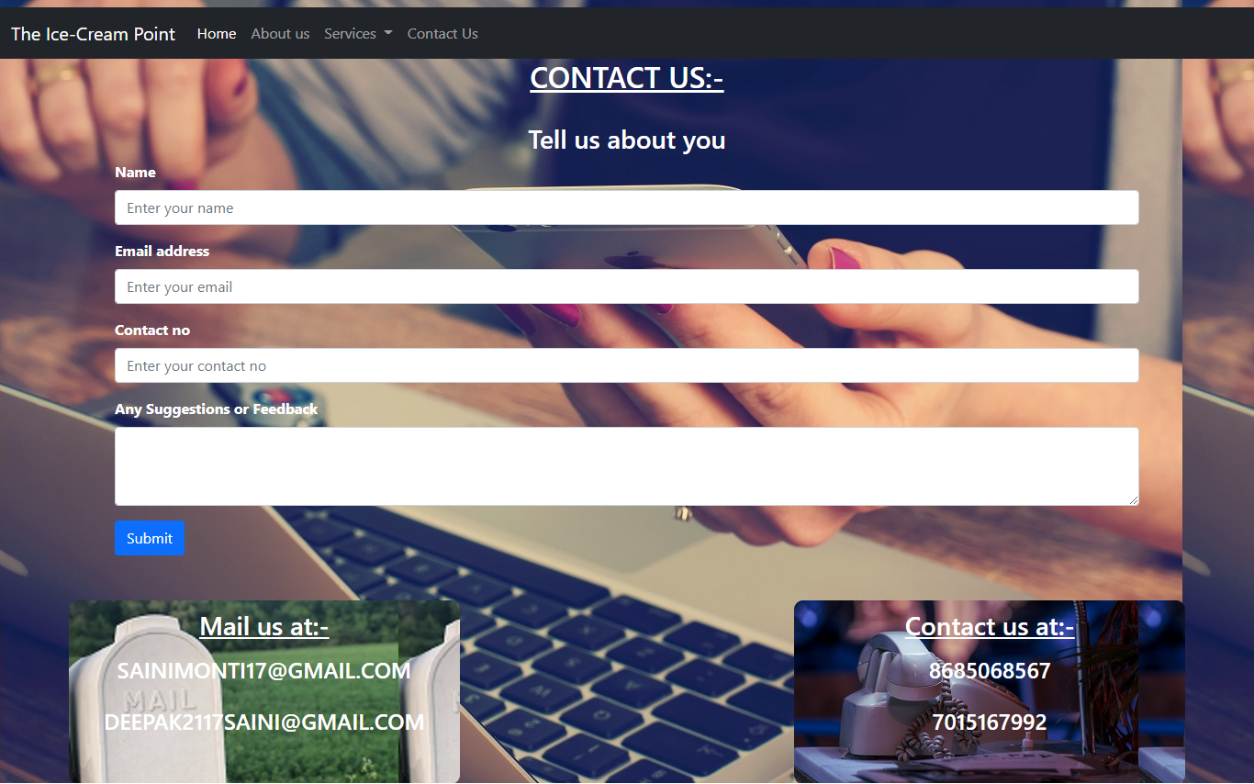

**BACKEND:-**

**LOGIN:-**

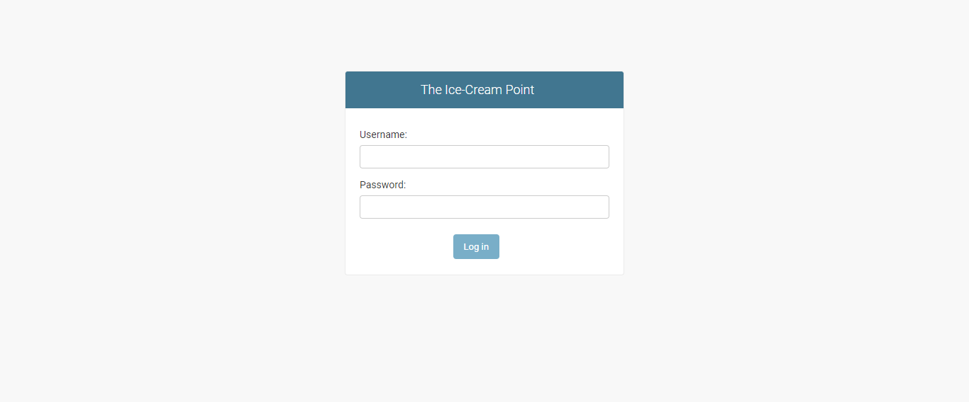

**HOME BACKEND:-**

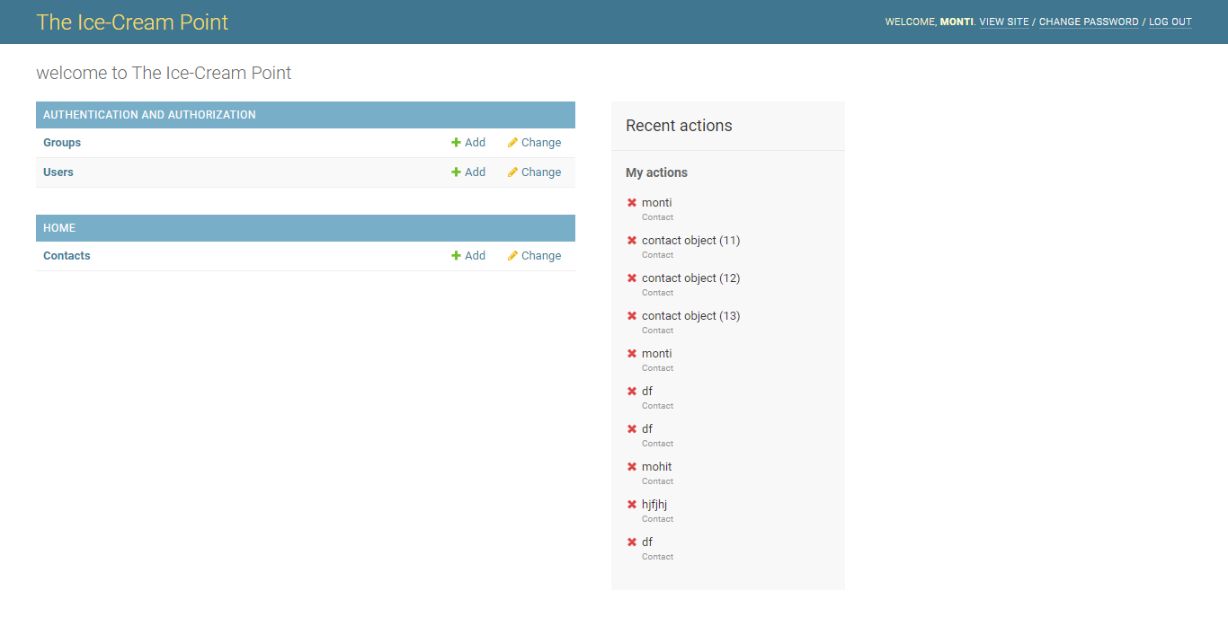

**TABLE:-**

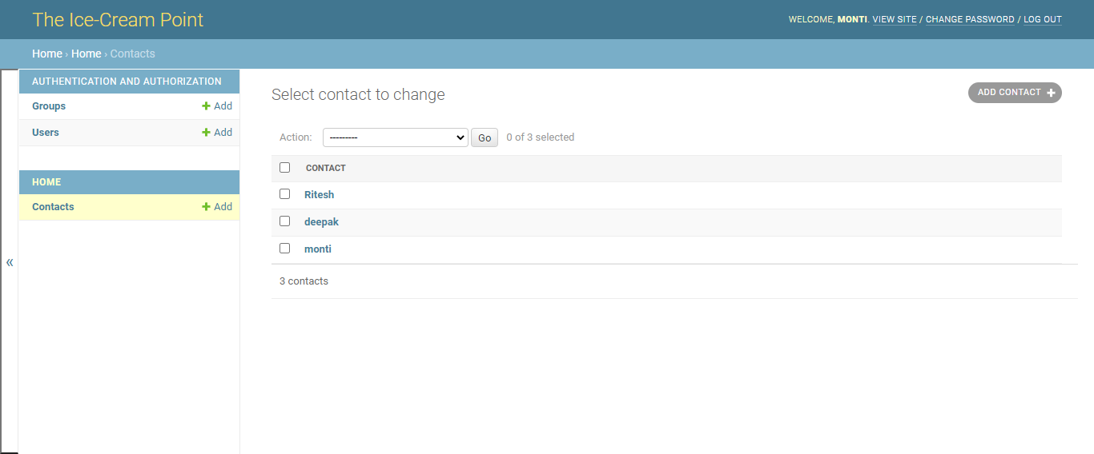

**TABLE DATA:-**

